AI use case: POC hydrological state reporting using an MCP server for VMM data on waterinfo.be
1. Main area
Select the area to which the use case primarily belongs:
☐ Strategy, Governance and Organisation
☐ People, Skills and Ways of Working
☐ Data, Technologies and Infrastructure
■ AI Applications and Value Creation

2. Challenge or opportunity
The waterinfo portal (https://waterinfo.vlaanderen.be) is a collaborative effort between several governmental bodies in Flanders, active in the water sector. At VMM, we operate and maintain the measurement networks on the non-navigable waterways. The information (measurement timeseries, radar imagery, …) is available through a dedicated API (KiWIS by Kisters AG).
- waterinfo.be data (levels, discharge, precipitation, physical- and chemical parameters, radar-derived QPE) is only accessible via the KiWIS REST API requiring knowledge of how the API works as week as.

- Compilation of hydrological bulletins today means manually cross-referencing multiple stations/catchments and sometimes external sources, which is time-consuming and depends on a small pool of API-literate data scientists.

- Rising demand (management, crisis cells, other agencies) for fast, plain-language answers on current water status without going through GIS/API tooling.

- MCP is emerging as a standard way to expose existing APIs as LLM tools without rebuilding the underlying data infrastructure.

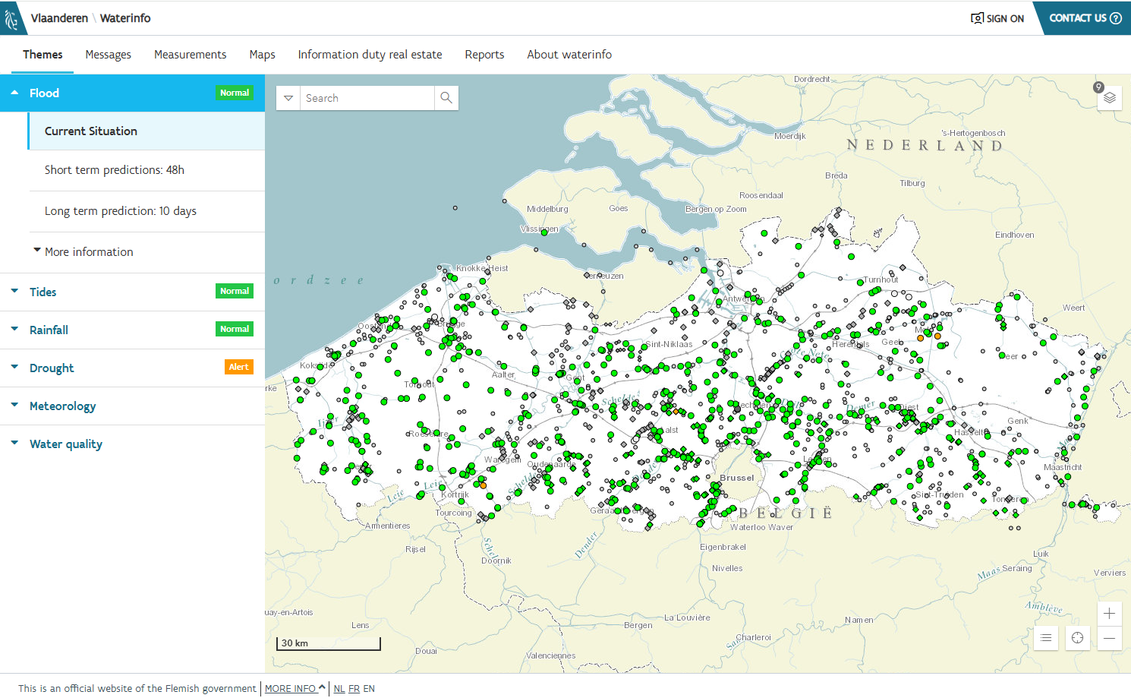

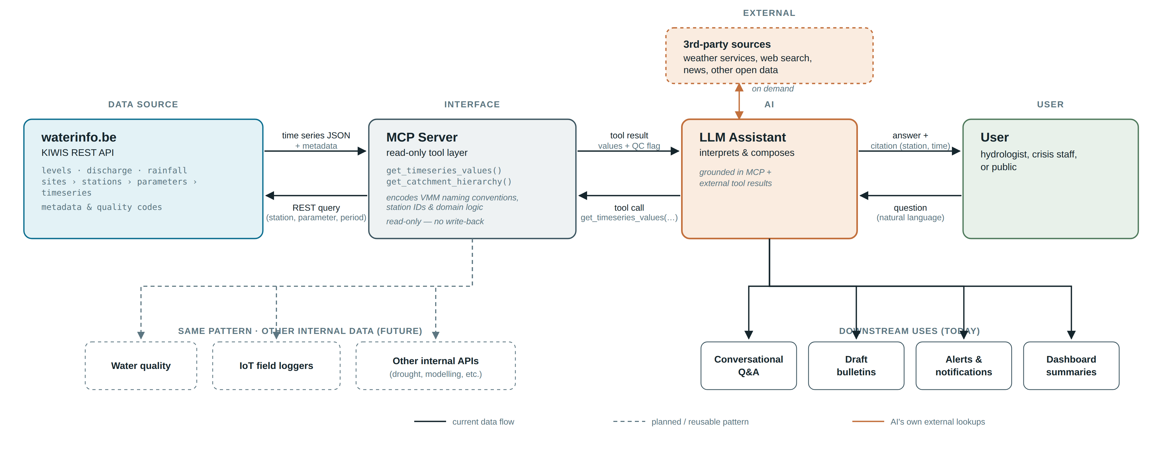

3. Proposed use of AI
- An MCP server wraps the existing KiWIS API and allows to encode specific ways in which the datamodel has been organized. the KiWIS API is fairly generic, however, how the data model, naming conventions etc are organized is entirely up to the user and thus deployment-specific. So the MCP server should capture this
- The MCP is exposed such that an LLM is able to call it using natural language processing : “what is the current discharge at station X”, “how much did it rain the last 24 hours in catchement Y”, …
- The LLM, in reasoning mode is then able to identify the right tools in the MCP as well as combine this information with third party sources when confronted with more complex inquiries such as “Summarize the hydrological state of Flanders for the past week, treating water level, discharge and rainfall” for example.

Below is the output for exactly this prompt using Anthropic Claude OPUS 5.

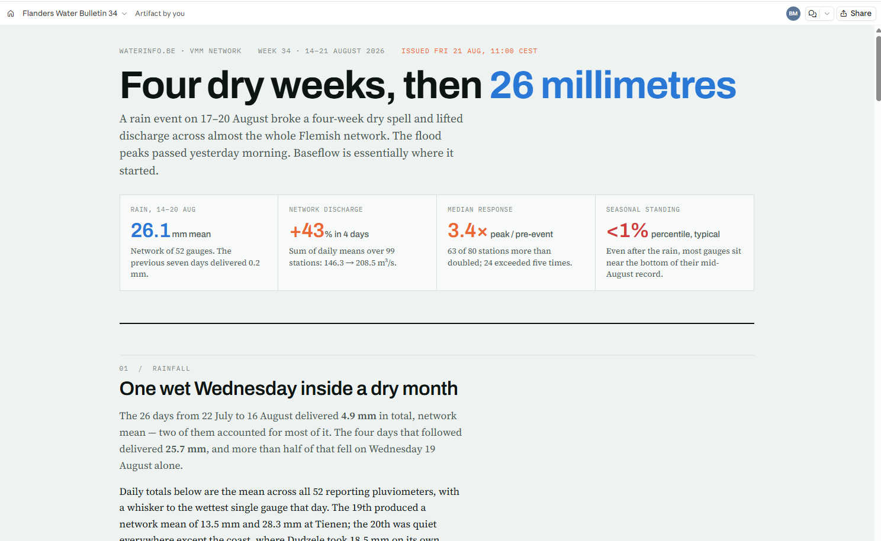
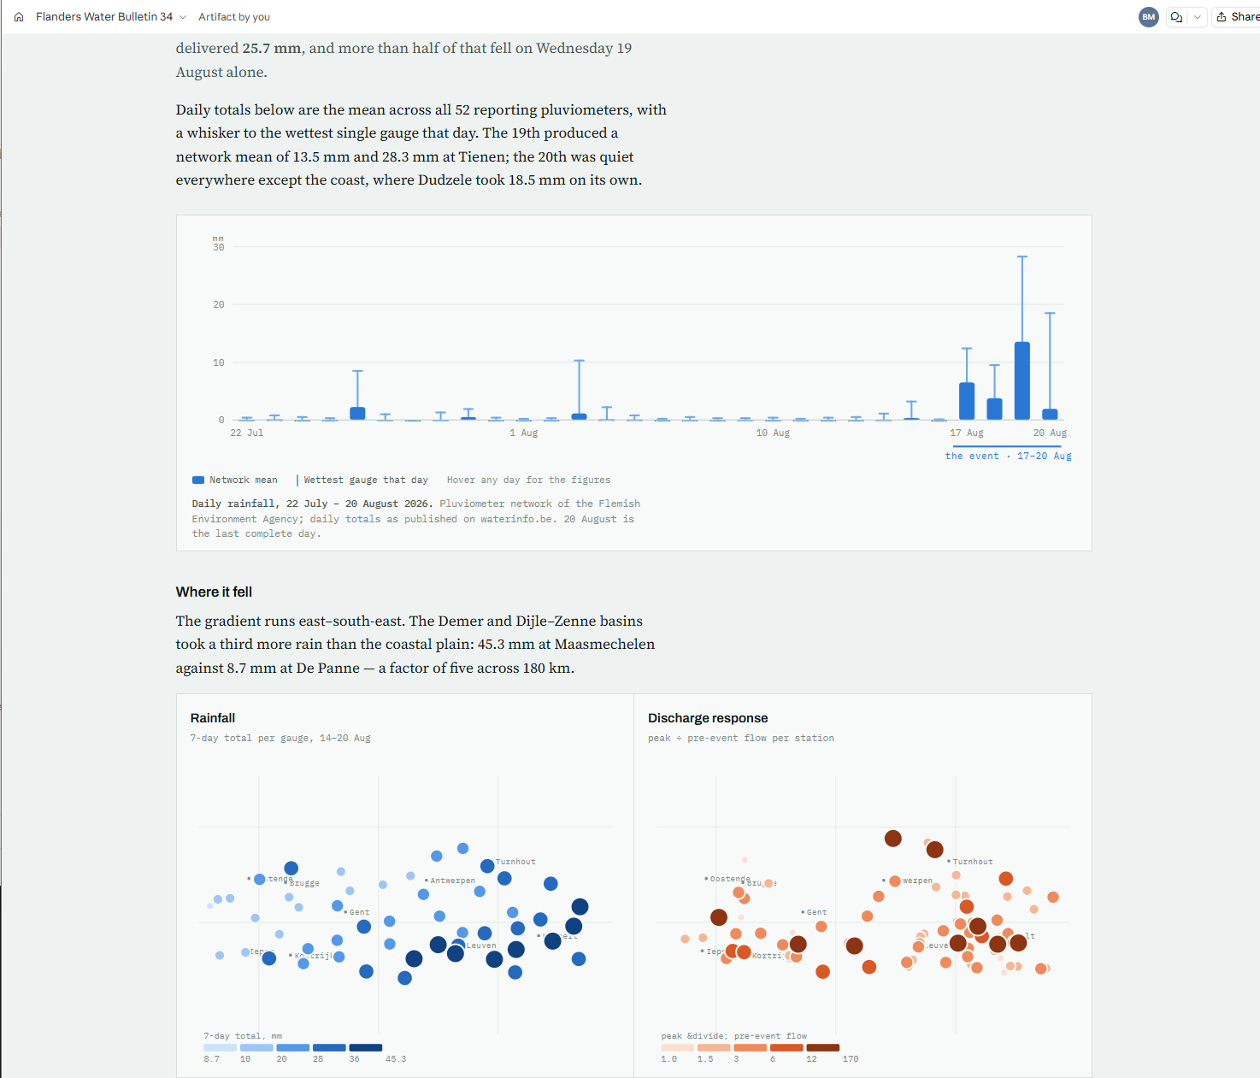
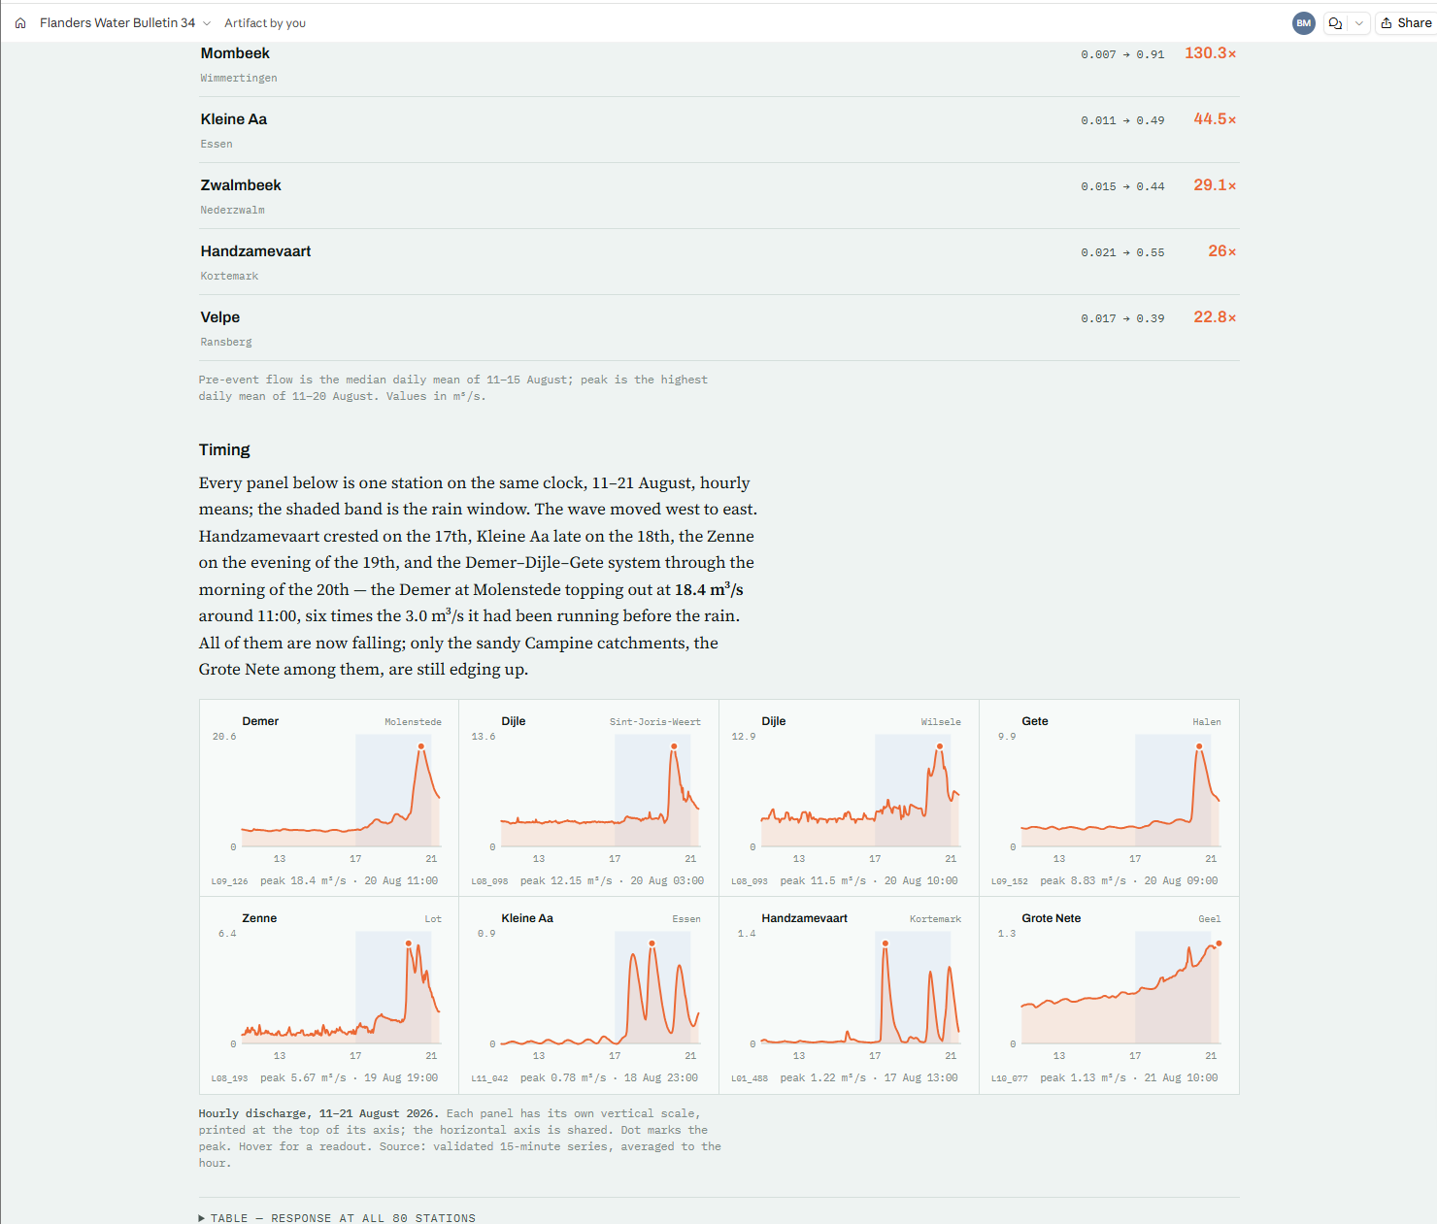
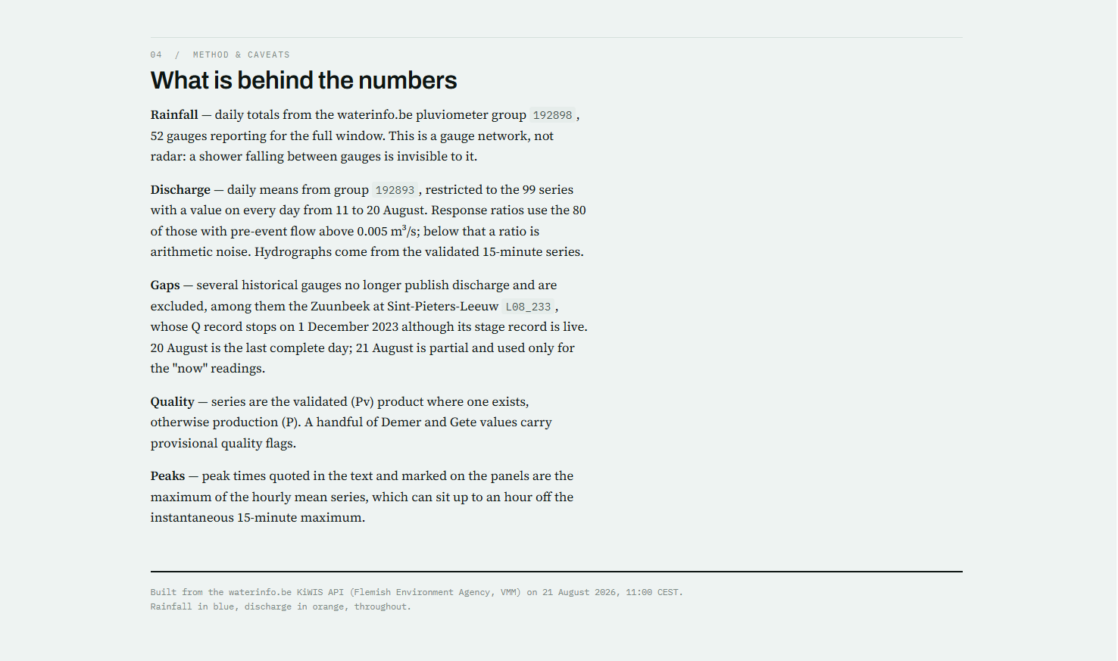

Interesting observations of what is produced automatically, without asking explicitly:
- Averages, medians over basins, speaks of baseflow (both of which are hydrologically very relevant), without asking.
- Rainfall and discharge maps
- Correctly identified (by merit of the MCP) the relevant timeseries in the database (e.g. Dag.Percentielen(14d-Jaar) to get the discharge percentiles (14day averages) for the time of the year
- Is honest about gaps, quality peaks and data origins (timeseries groups).
- Links soil texture to station location, without the data explicitly being linked in the KiWIS or MCP, so this assessment comes from other data sources the LLM accessed in order to fully analyse the data.
- Admittedly beautiful visualisations

On the other hand, produces sums and medians per basin of discharge, which are not necessarily representative for the basin -> here expert judgement needed.

4. Scope
Define what is included in the use case and set its boundaries.
- Covered: read access to waterinfo.be measurement stations, time series (level, discharge, precipitation) and metadata via the KIWIS API, exposed through an MCP server to an LLM interface.
- Users: VMM hydrologists and water managers, crisis/emergency staff, possibly other Flemish agencies or the public in a later phase.
- Data: near-real-time and historical time series, station/catchment metadata, rating curves, data-quality flags, radar imagery, …
- Out of scope: write/actuation capability, forecasting or modelling logic, non-VMM data sources

5. Expected outcome
Describe the concrete result that the use case is expected to deliver.
- Ability to interact with the waterinfo.be measurements via natural language without understanding the technicalities of the API, webinterface or programming languages
- Ability to better link different sources of information together when compiling hydrological information bulletins, where nowadays,
- Noticeably shorter time to compile a hydrological bulletin, and perhaps with novel insights
- A wider group of staff can query live water data directly, without needing API or GIS skills, this can be demonstrated by adoption outside of the current small-ish group of data scientists & API -users.

6. Contribution to the environment and digital agenda
Explain how the use case supports both environmental objectives and digital development.
Environmental:
- improves timely access to hydrological monitoring data for staff and decision-makers
- supports faster situational awareness during high-water events (or droughts)

Digital:
- demonstrates responsible reuse of an existing, well-governed API (KIWIS) rather than building new data pipelines; the MCP pattern is directly reusable for other VMM data sources (radar QPE, water quality, IoT loggers);
- builds internal AI/MCP tooling capability and therefore integrates directly the knowledge of VMM experts on the database structure, naming conventions, best practices in building queries (performance wise), quirky features of the data model, …
- Central MCP server allows better governance and quality control w.r.t; distributed plugins
- keeps the AI use read-only and traceable to source data, supporting explainable and trustworthy AI in a public-sector setting.
7. Key conditions and considerations
Identify the most important requirements, dependencies or risks.
- Provisional vs. validated data status must be surfaced clearly in LLM responses to avoid decisions being made on unvalidated measurements, KiWIS API exports this information, but the data model (quality codes) needs to be baked into the MCP
- MCP server must enforce read-only access — no write path back into KIWIS: security!!
- Human expert oversight required for anything safety-relevant (e.g. flood-related bulletins); LLM output should be reviewed, not published unchecked!
- Explainability: responses should always cite station ID, timestamp and parameter so a hydrologist can verify manually against the source. Also spokespersons should fully understand the generated contents -> danger of just sending AI generated contents without proper understanding
- Skills / capacity: needs some in-house MCP/LLM integration knowledge alongside existing KIWIS expertise as well as domain/deployment specific knowledge
- Infrastructure: hosting within VMM's managed environment (proxy/Group Policy constraints) and secure network access to the KIWIS API.
- Importance of well-governed, structured back-end data sources, accessible via standardized API.
- Reuse/scaling: same MCP approach could later cover radar or water-quality data — worth designing the server generically from the start.
- Scaling on technology level: unnecessary API calls from the MCP: optimization or perhaps throttling needed look at technological scalability
- Regulatory: should be aligned with Flemish/EU AI governance expectations for public-sector AI, given the water-safety context, though: monitoring only

